Title：14-point boldface, Time New Roman font, Align center, Single space∗

Presenting author ª, Author ^{b}, Author ^{a b}, Corresponding author ^{a *}
ªAuthor’s affiliation, city, zip code, country
^{b}Author’s affiliation, city, zip code, country
*Corresponding author’s e-mail address

Keywords: (Time New Roman font, 12- point, no more than 5 words）

This is a template of abstract for the 19th NCC, Chongqing, China, 2019. You can directly use this template without changing the format. Main text is given in 11-point with Times New Roman font and 1.25 times line spacing and indentation of the first line with two characters ^{[1]}.
Please fit the abstract to 1 page of A4 sized paper (including charts), single-sided with a top margin of 25 mm and side and bottom margins of 20 mm. Each participant user can only upload one abstract. Uploading files in PDF format is strongly recommended, to avoid formatting errors^{[1-2]}.

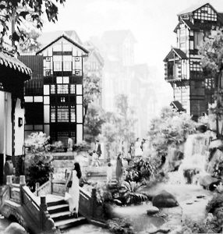

Figure 1. The potograph of the famous scenic spot “Hongya cave” of Chongqing. (Captions of Tables and Figures are given in 9-point with one line spacing from the text body)

Please convert your Word file to PDF file and submit the PDF file on the website of 19 NCC (http://19ncc.medmeeting.org/en). To avoid garbled printout, all the fonts should be embedded in the PDF file, which can be checked in the property of document. The simplest way of embedding fonts is to select "High Quality" in property when you make a PDF file (at the same time the quality of pictures and drawings is kept). Please note that the final PDF file that is to be uploaded should not exceed the size limit of 3 MB.The deadline of submission is June 14, 2019.

References
1. A. B. Author, C. D. Author, et al., J. Am. Chem. Soc. 2019, 1: 1-5.
2. A. B. Author, C. D. Author, et al., J. Am. Chem. Soc. 2019, 1: 1-5.

∗ Natural Science Foundation of China (12345678) and Chongqing (12345678)

