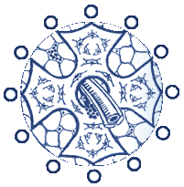
ARCO International

The Association for the Research in Bone Circulation/ Osteonecrosis

February 14, 2019

Invitation Letter

Dear ,

We have the pleasure to invite you to participate in the Association Research Circulation Osseous (ARCO), which will take place in Dalian, China from 2-5 May 2019.

Travel expenses, accommodation expenses, congress fees and maintenance will be covered by organizer, however, all medical costs in case of illness or hospitalization during your stay in China will be paid by yourself.

Necessary information of your person for the embassy:
Name:
Date of birth:
Passport no:
Term of visit:

Best regards

Dewei Zhao
Congress President
Dalian International Conference Center, Liaoning Province, China.
Tel: 86-411-62893509 http://arco2019.medmeeting.org/
Arcochina2017@163.com

