Open-cage [60]Fullerenes as Potential Oxygen Delivery Material

Zishuo Zhou, Liangbing Gan
College of Chemistry and Molecular Engineering, Peking University, Beijing, China
E-mail: gan@pku.edu.cn

Please prepare your abstract for Oral or Poster using this template. The title is Arial or Helvetica font, 14 point, all other items except the references are Arial or Helvetica font, 12 point, and the references are Arial or Helvetica font, 10 point.¹⁻² The text is single line spacing. The page setup is A4. Your one-page abstract should include a graphic, such as the example shown below.

Please submit your abstract in both PDF and Word file formats as a single compressed file by July 31, 2020.

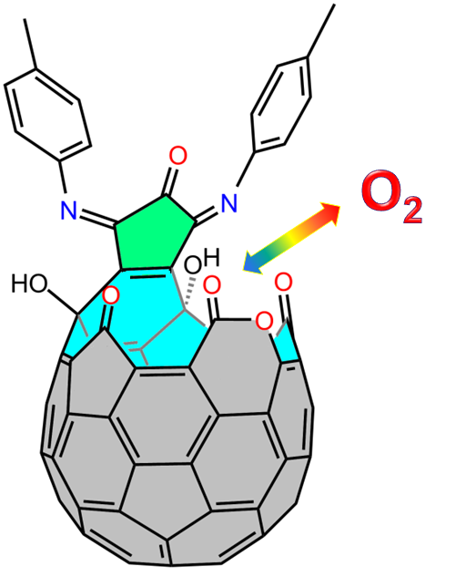

References
- Z. S. Zhou, N. N. Xin, L. B. Gan, Chem. Eur. J. 2018, 24, 451.
- Y. B. Li, G. H. Zhang, D. Wang, B. D. Xu, D. Xu, N. Lou, L. B. Gan, Angew. Chem. Int. Ed. 2016, 55, 14590.

